El Dorado County

Invites applications for

Supervising Public Health Nurse

Annual Salary:
$73,466-$89,294

PLUS:
*A signing bonus of up to $6,000 will be paid over 26 bi-weekly pay periods.
*Where the selected candidate lives over 100 miles from the assigned work location,
Reimbursement of ACTUAL moving expenses, up to $5,000, will be available.

Filing Period
Opened Until Filled
El Dorado County

One of the most scenic experiences in California, El Dorado County extends from Folsom Lake and the surrounding foothills, through the pine-covered Sierra Nevada Range to Lake Tahoe at the Nevada border.

The area’s beauty is matched by the many recreational opportunities, including skiing, boating, river rafting, hiking, fishing and camping. More than half of the County’s 1,805 square miles consists of National Forest and other recreation areas, including the world famous Rubicon Trail. The County’s 10,000 foot mountain peaks, 200 lakes and 682 miles of rivers make the area ideal for outdoor enthusiasts. Those with a more relaxed sense of recreation may also enjoy the rich Gold Rush history, and nearly 100
wineries.
With 180,000 residents, El Dorado County features a diversity of living styles, including country and executive homes, rural estates, view properties, homes with nearby golf courses and air-parks. Whether on the east or west end of the County, you are only an hour away from either the Sacramento or Reno Airport, making air travel easy and convenient. The County also has some of the best and highest performing schools in the State.

A Unique Opportunity
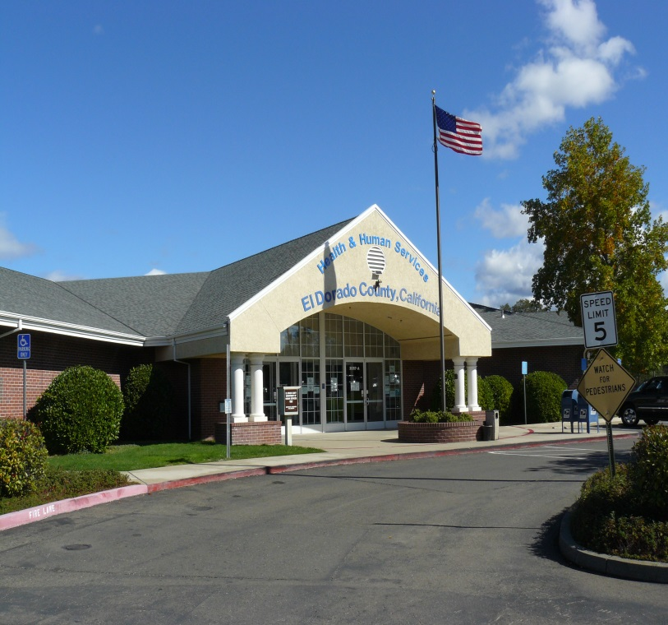
For the fifth consecutive year, El Dorado County has ranked among the top ten healthiest counties statewide in an annual report by the University of Wisconsin Population health Institute and the Robert Wood Johnson Foundation. The “County Health Ranking” report released in March 2015, ranked El Dorado County 7th healthiest among the 57 ranked counties in California. The County received high marks for its quality of life, excellent educational opportunities, decreasing unemployment and low percentage of children in poverty. Additionally, the report shows the percentage of adults reporting poor or fair health is 10 percent in our County compared to 18 percent statewide. The Public Health division of the County’s Health and Human Services Agency is seeking a dynamic leader with the needed passion to continue this legacy.
The Position
The Health and Human Services Agency is moving toward an agency-wide nursing division model that will encompass all nursing personnel. The Board of Supervisors recently approved this position to enable the Health and Human Services Agency to provide nursing-specific supervision and training to all nursing personnel. This position is responsible for supervising and training of staff in addition to providing public health nursing services for the more complex client cases. Incumbents may also have independent responsibility for a major specialized public health program. The Agency is seeking a proven innovator who will be a progressive, energetic, responsive, politically astute, and confident leader to fill this role. The individual selected must thrive in a fast paced and dynamic environment with constantly shifting priorities and possess the creative vision to advance the Agency’s services.

Candidate Profile

The ideal candidate will possess the equivalent to a Bachelor’s degree from a four (4) year college or university accredited by the National League for Nursing AND two (2) years of public health nursing. In addition, possession of a valid license to practice as a Registered Nurse in the State of California and a valid California State Public Health Nursing Certificate are required. The ideal candidate:

- Provides leadership, best practice review and oversight for specialized health programs and population based services, such as Maternal Child Adolescent Health (MCAH, California Children’s Services as well as a variety of pediatric/adult community based preventive services
- Conducts fiscal planning and budget or grant preparation including strategic planning for budget or grant implementation.
- Conducts assessments of individual, family, community and at risk population assets, needs, values, beliefs, resources and environmental factors.
- Conducts physical assessments, dispenses pharmaceuticals, performs diagnostic testing, reviews and interprets laboratory findings and provides intervention in accordance with standardized procedures and protocol at the facility level and in the field.
- Evaluates the effectiveness of public health intervention through ongoing assessment of the individual’s physical condition and behavior, signs and symptoms of illness, and reactions to treatment, interpretation and analysis of community level epidemiology, effective communication with community systems of care and qualitative research data.
- Coordinates services provided those of private, public and community voluntary health and social service agencies; serves as liaison to community groups, assisting them in identifying health needs, and providing public health education.
- Plans, organizes, supervises and reviews the work of assigned professional and support staff.
- Selects staff and provides for the orientation, training and evaluation of staff; recommends discipline and other personnel decisions.
- Provides technical consultation and guidance to staff members on difficult client cases.
- Monitors and evaluates programs, projects and special services; prepares a variety of periodic and special reports for appropriate management review.
- May represent the Division or Agency in meetings with community partners, other agencies and the public.

Compensation and Benefits
The annual salary range for this position is $73,466-$89,294. The salary is negotiable within the stated salary range and may be adjusted based on the selected candidate’s experience and qualifications.

Benefits Include:

• CalPERS (Miscellaneous) 2% at 62, based on the highest average annual pensionable compensation earned over a consecutive 36-month period
• Health/Dental/Vision Insurance
• Deferred Compensation Plan
• El Dorado County does not participate in Social Security, but does participate in Medicare
• $20,000 Paid Life Insurance
• Long Term Disability Insurance
• 16 hours Supervisory Leave per year
• 96 hours Sick Leave annually
• 10-20 days Vacation Leave annually (depending on length of service)
• 13 Paid Holidays (includes two Floating Holidays which are granted based on date of hire)

Application and Selection Process

Please submit your application on-line at http://agency.governmentjobs.com/edcgov/. All completed applications will be reviewed and the most suitably qualified applicants will be invited to participate further in the selection process. Prior to employment, all candidates will undergo background screening.

If you require assistance with the application process, please contact the El Dorado County Human Resources Department at (530) 621-5565.

For a full job description and requirements visit http://agency.governmentjobs.com/edcgov

El Dorado County

EEO/ADA Employer and a Drug Free Workplace

